StarPlanner | 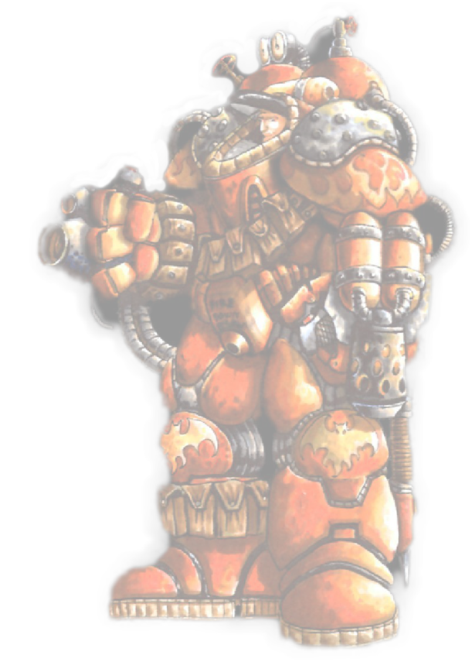  Demonstrating a Goal-Oriented Action Planning for RTS  Panagiotis Peikidis (CITY College)

Introduction
Planning in video games has been rapidly spreading from the first implementations in an FPS to the latest installment of the Total War series. Currently there is a vast amount of research going on in the area of video game planning, from HTN planners to Case-Based Planning and many-many more.
StarPlanner implements the Goal Oriented Action Planning agent architecture for the very famous RTS game Starcraft.

Architecture
Abstraction is the center of StarPlanner’s architecture. From the system itself all the way to the strategic planner, many elements are abstracted away to provide extensibility.
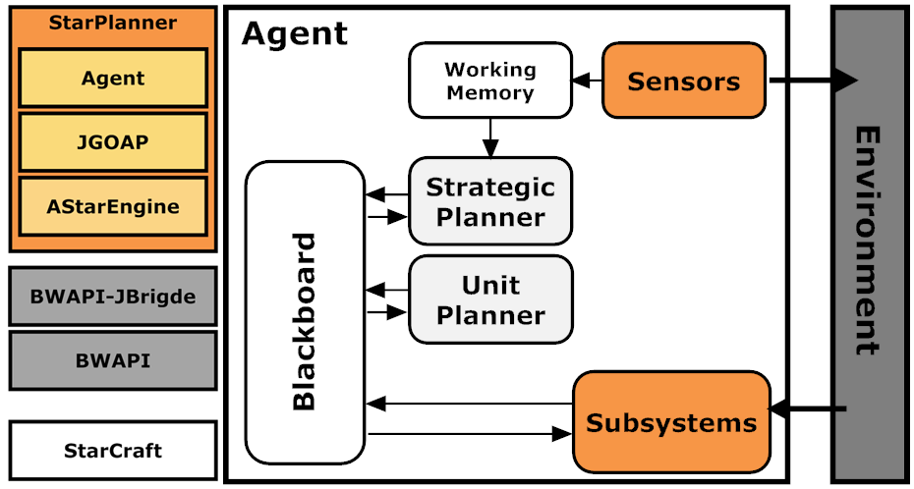
Figure 1 StarPlanner’s System Architecture (left)
and Agent Architecture (right)
StarPlanner has been divided into:
- A* Engine
- GOAP Engine
- Agent
This makes it possible to integrate GOAP in any other architecture.
Abstraction is also available at the planning level, where facts about the environment are stored into the working memory and complex calculations at the blackboard. These are both used to optimize planning.

Planning
StarPlanner performs planning in two levels:
- High Level Strategic Planning
- Mid-Level Unit Production Planning.
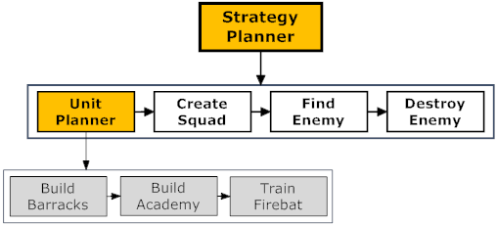
Figure 2 StarPlanner's Plan

Communication between the strategic planner and the unit production planner is done using the blackboard. All low level actions are performed by the systems low-level managers:
- Building Manager
- Training Manager
- Squad Manager, etc.
These managers report back to the corresponding planner. Thus, plan invalidation and re-planning is possible.

StarPlanner Manager
StarPlanner also provides a tool that users can customize the behavior of both planners (Strategic and Unit Production).
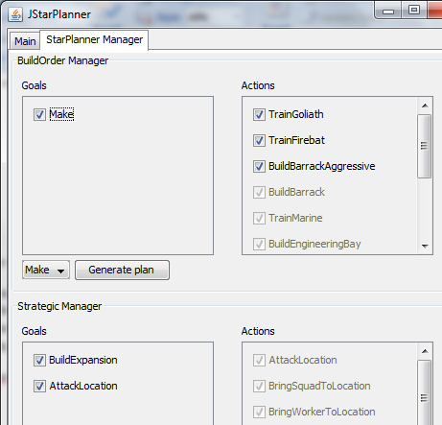
Figure 3 StarPlanner's Planner Manager
Users can activate and deactivate goals or actions on the fly or before StarPlanner initiates.

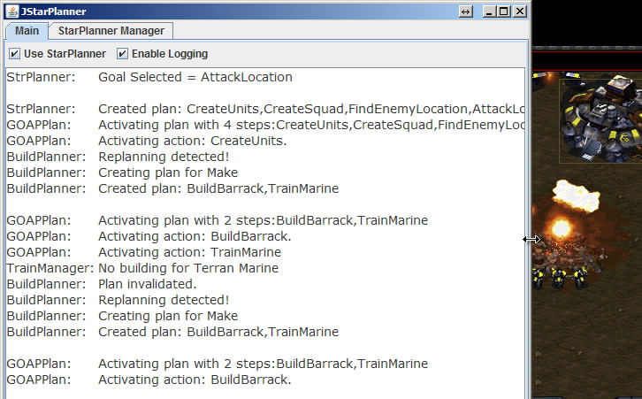
Figure 4 Unit Production Replanning

Issues
- Symbolic World Representation
- Total-Order Plan
- A* Weights
- Many more…

